VALLEY CHRISTIAN ACADEMY

PRESCHOOL thru 8TH GRADE

2022/2023

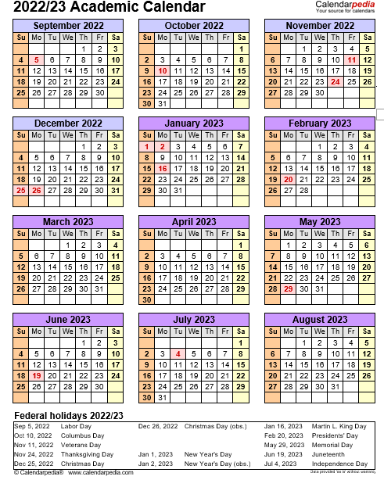
Start of School 2022/2023:
September 6 First day of school

Minimum Days (dismissed at noon):
April 24-27 K5-5th Grades Mandatory
Achievement Testing

April 24-27 6th-8th Grade Mandatory

Achievement testing

End of Year:
June 9 Last day of school
Preschool -8th Grades

No School:
October 10 Columbus Day
November 10 Teacher In-Service Day
November 11 Veteran’s Day Observed
November 21-25 Thanksgiving Break
December 23-Jan 6 Christmas Break
January 16 Martin L. King, Jr. Day
February 20 Presidents’ Day
February 21 Teacher In-Service Day
March 13 Teacher In-Service Day
April 3-10 Easter Break –
Start Back on Tuesday
April 11, 2023
May 1 Teacher In-Service Day
May 29 Memorial Day

Ending Quarters:
November 4 1st Quarter ending
January 27 2nd Quarter ending
March 31 3rd Quarter ending
June 9 4th Quarter ending

Graduation Date:
June 13 (Tues) K5 (8:30 a.m.)
June 13 (Tues) 8th Grade (10 a.m.)

Daycare Closed Dates:

October 10 Columbus Day

November 10 Teacher In-Service Day
November 11 Veteran’s Day 12
Additional Dates:

TBD Picture Day
TBD Picture Re-take Day
April 13 Walk-A-Thon
May 4 National Day of Prayer

November 23-25 Thanksgiving Break
December 23-27 Christmas Break
January 2-3 Christmas Break
January 16 Martin L. King, Jr. Day.
February 20 Presidents’ Day
February 21 Teacher In-Service Day
March 13 Teacher In-Service Day
April 7 Good Friday
April 10 Easter Break

May 1 Teacher In-Service Day

May 29 Memorial Day

July 4-5 Independence Day Weekend
August 28 –Sept 4, 2023 Week Before School

“But I trusted in thee, O Lord:

I said, Thou art my God. My times are in thy hand.”

Psalms 31:14-15a

