VALLEY CHRISTIAN ACADEMY

High School Calendar

2022/2023

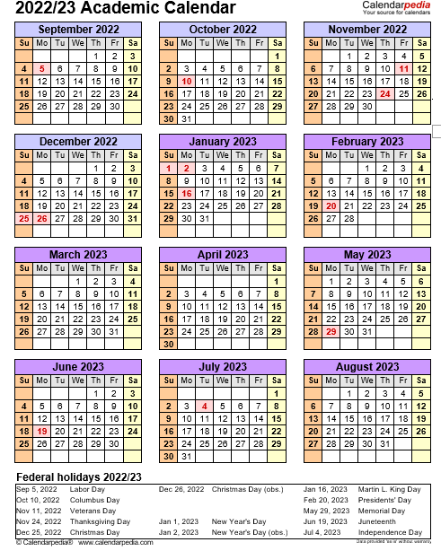

Start of School 2022/2023:
September 6 First day of school

Minimum Days (dismissed at 11:45 a.m.):
September 6-10 First week of school
April 24-27 Mandatory - Stanford 10
Testing 9th -11th Grades
(no testing of seniors)

End of Year :
Last day of classes June 9
Mandatory Return books & clean lockers:
9th-12th June 9

No School:
October 10 Columbus Day
October 12 High School Testing Day
November 10 Teacher In-Service Day
November 11 Veteran’s Day Observed
November 21-25 Thanksgiving Break
December 23-Jan 6 Christmas Break
January 16 Martin L. King, Jr. Day
February 20 Presidents’ Day
February 21 Teacher In-Service Day
March 13 Teacher In-Service Day
April 3-10 Easter Break –
Start Back on Tuesday
April 11, 2023
May 1 Teacher In-Service Day

May 29 Memorial Day

Ending Quarters:
November 4 1st Quarter ending
January 27 2nd Quarter ending
School Events:
Homecoming Football Game:
Homecoming:
Walk-A-Thon: April 13 (Thurs)
National Day of Prayer: May 4 (Thurs)

March 31 3rd Quarter ending
June 14 4th Quarter ending

Graduation Rehearsal:
June 14 (Wed) Seniors (9 a.m.)

Graduation Date:
June 15 (Thurs.) High School (9 a.m.)

Additional Dates:

TBD Picture Day

“But I trusted in thee, O Lord:

I said, Thou art my God. My times are in thy hand.”

Psalms 31:14-15a

October 12 (Wed) SAT – At VCA

October 12 (Wed) PSAT Testing

TBD Picture Re-take Day

.

